EXPT 5.2 : Implementation of an IoT-Based Smart Home Automation Network Using Cisco Packet Tracer

Objective:
(ii) To establish smartphone-based Wi-Fi connectivity for remote access and control of IoT devices, and verify wireless communication between the mobile device and the smart home network through the access point and IoT server.
Software/Apparatus required:
(i) Cisco Packet Tracer
(ii) End Devices (PCs)
(iii) Switches
(iv) Copper Straight-through Cable / Automatic Cable Selector
(v) Routers
(vi) Server (DHCP)
(vii) Household devices (Fan, AC, Light, Garage door)
Procedure:
Objective 2: Smartphone-based monitoring
1. Open the configured IoT smart home topology in Cisco Packet Tracer.
2. Add a Smartphone and ensure the Home Gateway/Access Point is active.
3. Configure the wireless network (SSID and password) on the Home Gateway.
4. Connect the Smartphone to the Wi-Fi network using the configured SSID.
5. Ensure the Smartphone obtains an IP address automatically.
6. Open the IoT monitoring application or web browser on the Smartphone.
7. Log in to the IoT Server using the registered user credentials.
8. Access the list of connected IoT devices.
9. Remotely monitor and control the Fan, Air Conditioner, Garage Door, and Light using
the Smartphone.
10. Verify that the device status changes according to the commands issued from the Smartphone.
Objective 2: Smart phone based monitoring
(DEFALUT)

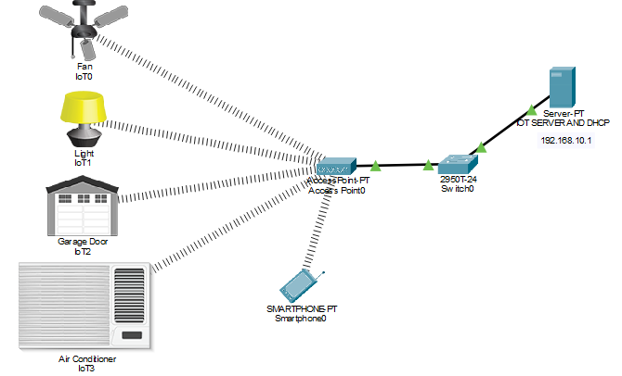

(CONTROL)
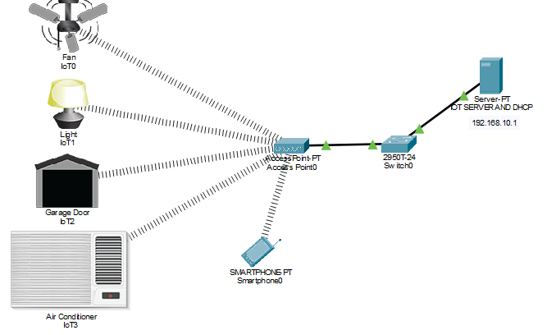

(SMART PHONE)
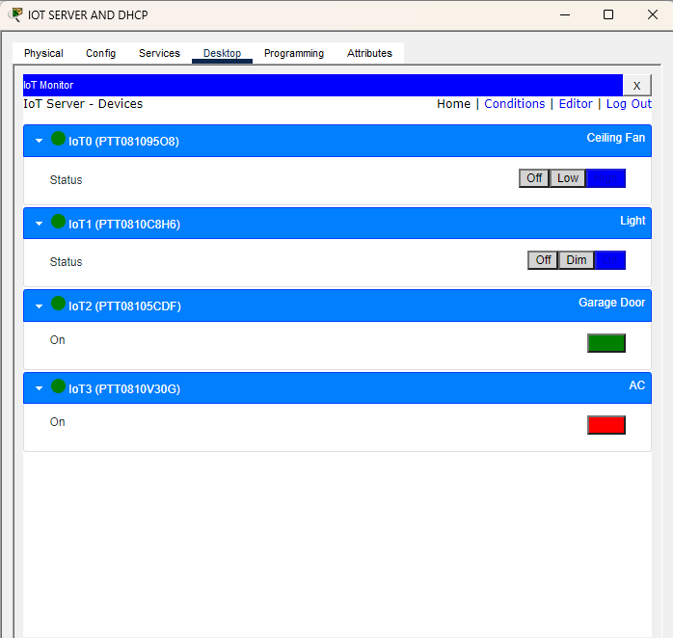

Objective 1: Smart Phone based monitoring
Things | Default | Control
Fan | Off | Low
AC | Off | On
Garage Door | Close | Open
Light | Off | Dim

Result:
Objective 2: Smart phone based monitoring
The smartphone was successfully connected to the Wi-Fi network and was able to remotely monitor and control the IoT devices.

